**Java Principles**

***OOP Concepts Questions:***

1. **What is the difference between *Interface* and *Abstract Class* (Java 8)?**
2. **Explain *Encapsulation* vs *Abstraction*.**
3. **What do I need to implement to make the following code work as expected?  
   **
4. **What is the risk of the following code? What would you do to reduce that risk?  
   (Assume that *x* is not null)  
   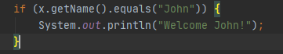**
5. **What is the problem about using the following code? (The Law Of Demeter)  
   **
6. **Which Java Collection is less efficient for *get* method?**
   1. **LinkedList**
   2. **ArrayList**
   3. **HashMap**
7. **What is JVM?**
8. **What is the difference between *overload* and *override*?**
9. **Show an example using *Inheritance* and the same example using *Composition*?**
10. **What is the violation in the following block of code?  
    